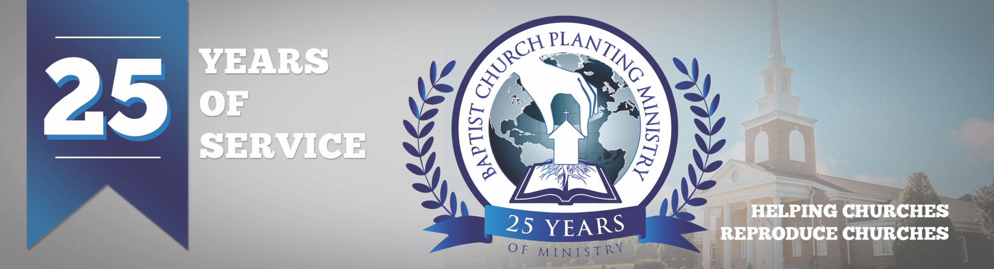

April 2018

We have received wonderful reports from the baby churches BCPM has assisted with over the last six months in Montana, Mexico, Alabama, and Florida. Each have seen salvations, baptisms, and growth. Pray for God to protect and provide for these churches as they mature. We are now in the process of working on church plants in Portugal, Arizona, Ohio, North Carolina and Italy and are in the preliminary stages of church plants in Canada and Washington. This can be up to a two-year process as we help strategize, evangelize, and organize for the new baby churches. Pray for the preparations and for the Lord to be glorified as we seek His leading in these.

We are just four months away BCPM’s 25th anniversary service and many are making plans to attend. We will be recognizing all the church planters and reproducing pastors who have used BCPM. We will also thank the Lord for what He has done and prayerfully will do through through our efforts. The special event will be held at 7pm on July 31 at South Haven Baptist Church in Springfield, TN.

We are truly thankful you for your continued prayer and financial support! Your investment is making a difference in world-wide church planting. Please make note of the new US mailing address for BCPM. All US support and mail should be mailed to our new mailing address at PO Box 387 Greenbrier, TN 37073.

Advancing in Christ,
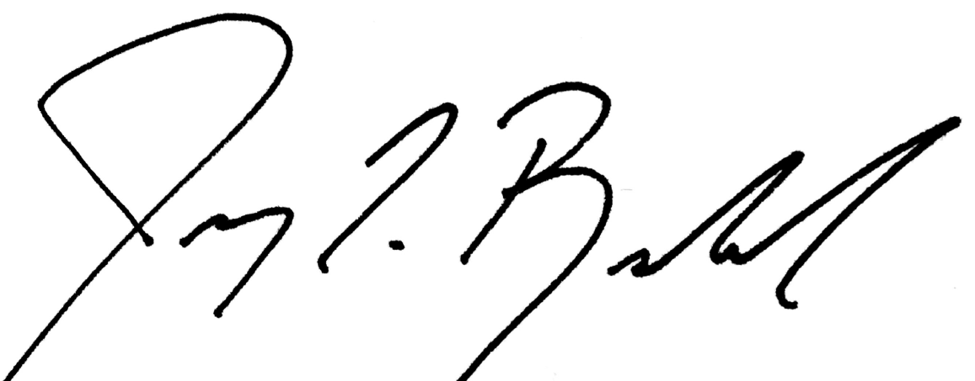

Jeremy Rowland,
General Director

